Fundamentals of ICT Lab 06 | Instructor: Ms.Quratulain
Program: AI Fall 2025 | Date: 11 DECEMBER,2025
Marks: 10 | Lab Engineer: Ms. Sibgha Noor
Student Name: Eshal Ayub | Reg. No: B25F1061AI100
Instructions:

- Submit the file with your names following your registration numbers like AI001_Name.
- Copy Paste work will be given no marks.


1. Introduction
This lab uses Excel to analyze hospital patient data. Formulas, conditional formatting, charts, and a PivotTable were used to evaluate recovery scores, identify high-risk patients, and compare department performance.
2. Methodology
A weighted Recovery Score was created using Treatment Score, Lab Tests, Doctor Consults, and Follow-up Visits. Categories (Excellent, Good, Needs Attention) and a High_Risk flag were added. Conditional formatting highlighted low scores, high-risk cases, and zero follow-ups.
3. Data Processing
- Recovery Score:
=F4*0.5 + (H4/MAX($H$4:$H$13))*10 + (I4/MAX($I$4:$I$13))*20 + (J4/MAX($J$4:$J$13))*20
- Category:
=IF(K4>=85,"Excellent",IF(K4>=70,"Good","Needs Attention"))
- High_Risk:
=IF(OR(G4>7,K4<60),"HIGH RISK","")
- Applied conditional formatting for risk and low scores.
4. Results
Recovery Trends
Summaries based on Recovery Score:
- Avg Recovery Score
- Excellent
- Good
- Needs Attention
High-Risk Patients
High-risk = Recovery < 60 or Days Admitted > 7. These patients require priority attention and follow-ups.
Department Performance (PivotTable)
PivotTable compares Avg Recovery Score, Total Lab Tests, and Avg Days Admitted for each department.
Chart 1:Avg Recovery by Department
Shows which departments have better recovery outcomes.
Chart 2:Bed Occupancy vs Recovery
Shows relationship between average days admitted and average recovery score. Longer stays = lower recovery in some departments.

5. Recommendations
- Increase follow-ups for low-performing patients.
- Support departments with longer admission durations.
- Improve treatment planning to reduce stay length.
- Ensure follow-up reminder system.
- Review low-score departments for improvement.

6. Conclusion
Excel analysis helped identify recovery patterns, risk factors, and department performance. The results support better planning, resource use, and patient care.
SCREENSHOT 1:
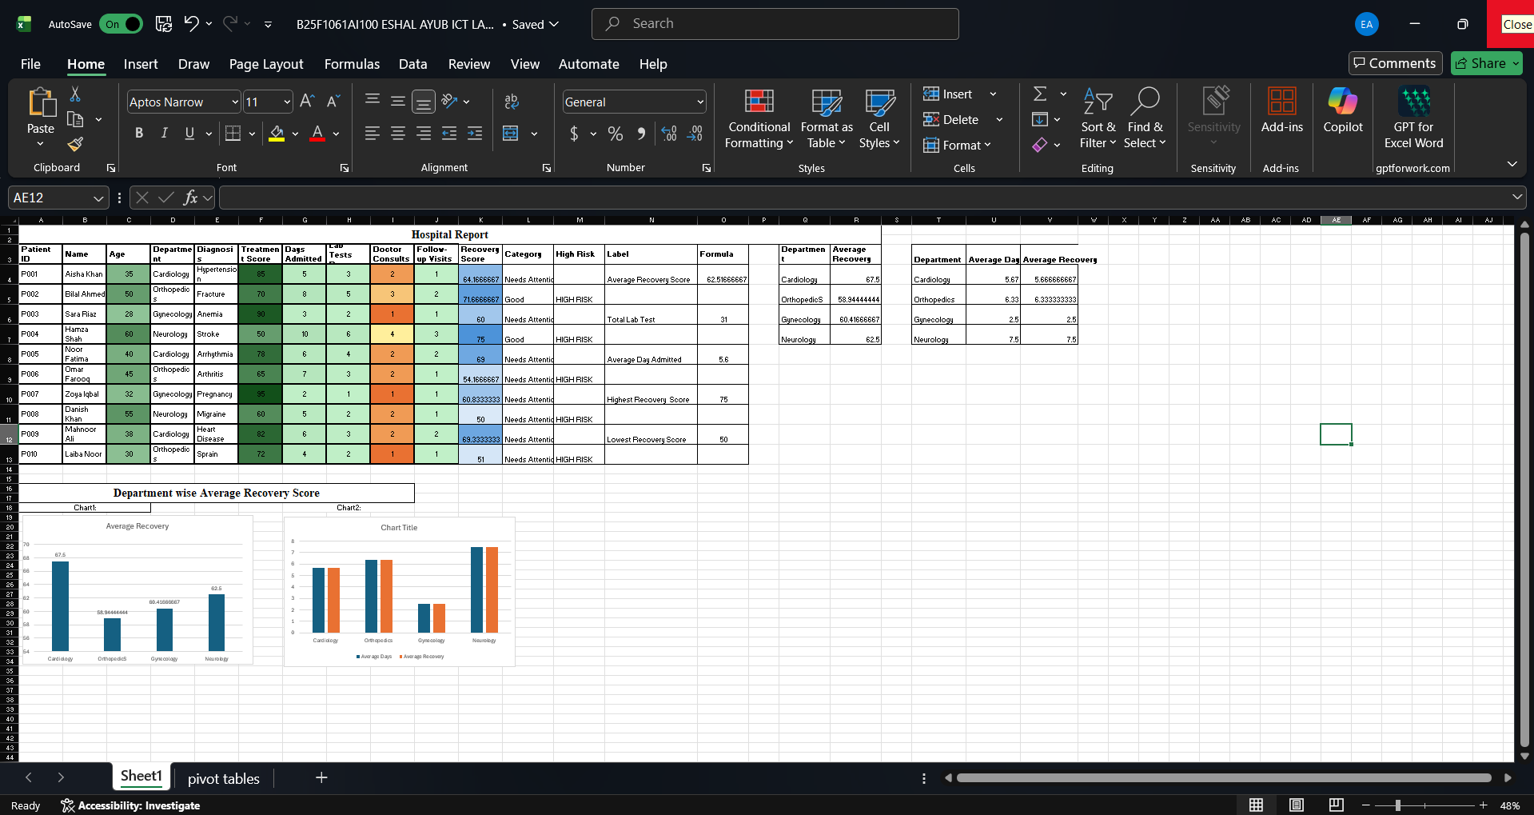

SCREENSHOT 2:
